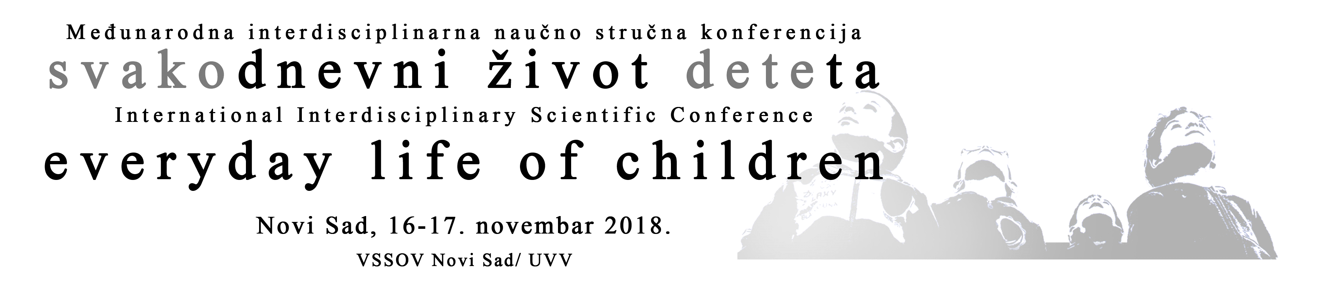

GENERAL REMARKS:

All attendances of the Conference are required to register participation by filling in the following form.
All the abstracts and applications are anonymously reviewed. The authors who submitted applications will receive feedback regarding the acceptance, necessary changes or rejection of the submitted topic (see important dates).
The organizer retains the right to suggest a change in format of the application (from a report to a poster and vice versa), according to the recommendation made by the reviewer.
The abstracts should contain the most important information about the research/topic: the research goals, the method, the most important results. It should not contain tables, graphs, or references. The abstract should refer to the basic goals of the presentation, the theoretical or practical implication of the paper. An abstract in English is required.
Duration of the oral presentations is limited to 10 minutes.
The authors of posters should be in front of their posters at the agreed time so that they can answer the questions from the audience.
The authors and publishers of publications/didactic materials may schedule a particular hour at which they will promote their work (maximum duration is 60 minutes), the guests are exempt from paying the registration fee, or they can utilize the hallway of the school and set up a permanent exhibit which will remain on display for the duration of the Conference.
All the authors of oral, poster, as well as other forms of presentations are paying the registration fee and are thus entitled to the accompanying material, certificates, as well as publication in the Book of Abstracts.

APPLICATIONS FOR THE CONFERENCE SHOULD BE SENT TO THE FOLLOWING ADDESSS: szdns2018@gmail.com
The deadline for submitting applications and abstracts is 1st September, 2018

APPLICATION FORM AND ABSTRACT SUBMISSION

A) PERSONAL INFORMATION

Participant’s full NAME;
first author; discussion moderator; workshop coordinator; publication representative
Academic title:
Affiliation/institution:
E-mail address:
(For participants who submitted their papers):
Full name, academic title, affiliation and e-mail address of the other authors of the submitted abstract
- INFORMATION ON MANNER OF PARTICIPATING

Registration for:
(Underline or mark with bold typeface)
1.) oral presentation
2.) poster presentation
3.) discussion group
4.) workshop
5.) presentation of a book/didactic material
6.) passive participant
ABSTRACT SUBMISSION
- ORAL PRESENTATION
Presentation language:
Title of the presentation:
Summary in the presentation language:
(up to 500 words)
Key words:
(up to 5 words)
Title of the presentation in English:
Summary in English:
(up to 500 words)
Key words in English:
(up to 5 words)
- APPLICATION FOR POSTER PRESENTATION

Presentation language:
Title of the poster presentation:
Summary in the presentation language:
(up to 500 words)
Key words:
(up to 5 words)
Title of the presentation in English:

Summary in English:
(up to 500 words)
Key words in English:
(up to 5 words)
- APPLICATION FOR DISCUSSION GROUP
Language of the discussion:
Title of the discussion:
Discussion goals:
(Brief description of the need/motivation for the discussion on the proposed topic; up to 500 words)
The names and affiliations of the suggested participants of the discussion (up to 8 participants, duration up to 60 minutes)
- APPLICATION FOR THE WORKSHOP

Language of the workshop:
Title of the workshop:
Workshop goals:
(up to 500 words)
Short description of the activities that show the link with the goals:
(up to 500 words)
Suggested number of participants:
Note: Planned duration of the workshop is 90 minutes. The coordinator provides the necessary material resources (paper, markers, other materials required). It should be specified here whether a video screen or a flip chart board is required (provided by the organizer of the Conference).
- APPLICATION FOR PRESENTATION OF PROFESSIONAL LITERATURE / JOURNAL / DIDACTIC MATERIAL
Title of the publication:
Author/authors; year; publisher:
Short excerpt from the review and rewievers’ names:
(up to 300 words)
For a journal:
(Title, publisher, short description of the field the journal specializes in)
For didactic material:
(Please state the publisher, author, short description of the purpose of the material, as well as the intended users)

